CISTO Supports iGrid 2005 Demonstrations

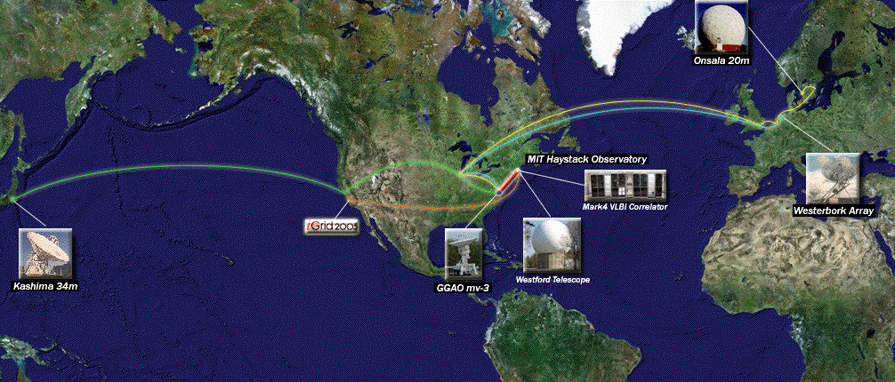
An iGrid 2005 demonstration of the electronic-Very Long Baseline Interferometry (e-VLBI) project correlated data from telescopes worldwide (Image credit: MIT Haystack Observatory).

Two live demonstrations went off without a hitch at the iGrid 2005 Workshop, with support from the Computational and Information Sciences and Technology Office (CISTO) High End Computer Network (HECN) team and their 10 gigabit-per-second fiber optic network. Using the DRAGON regional optical network and the National LambdaRail (NLR), data and video flowed 3,000 miles between Goddard Space Flight Center (GSFC) and the workshop site at the University of California, San Diego.

The California Institute for Telecommunications and Information Technology (CalIT2) hosted iGrid 2005 to encourage the development and use of high-speed optical networks. Researchers from 20 countries staged 49 exhibits during the workshop, which drew nearly 450 attendees September 26–29.

One exhibit featured the electronic-Very Long Baseline Interferometry (e-VLBI) project, a multi-national effort involving the GSFC Geophysical and Astronomical Observatory (GGAO) and the Massachusetts Institute of Technology (MIT). The demonstration used a technology called dynamic provisioning to automatically establish network connections between telescopes in Japan, the Netherlands, Sweden, and the United Kingdom. Live data from these telescopes were delivered at over 512 megabits per second to MIT, where they were correlated with data from GGAO in real time.

A second exhibit demonstrated a novel high-definition 3D video display system. Standing in front of a 4-foot-tall display podium, attendees could view holographic 3D video at HDTV resolution—without goggles or special headgear. The video originated from the HECN network lab at GSFC, where specially aligned HDTV cameras filmed a scene and encoded it for network transfer. The resulting data stream traveled through the DRAGON and NLR networks to the 3D display on the iGrid 2005 exhibit floor.

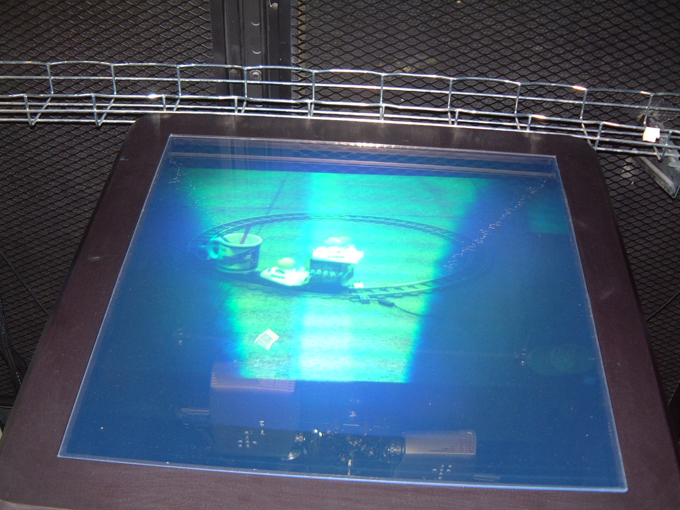
A True-3D display showed real-time, stereo-HDTV video transmitted from GSFC to the University of California, San Diego (Photo credit: Pat Gary, GSFC).

Echoing the theme of iGrid 2005, the HECN team emphasizes that high-speed optical networking services are available today within several GSFC facilities. Projects interested in using 10-gigabit networks to advance their research are invited to contact Pat Gary, Network Projects Leader in GSFC Code 606.1, at Pat.Gary@nasa.gov.

Related Links

IGrid 2005
http://www.igrid2005.org

e-VLBI Exhibit Page
http://www.igrid2005.org/program/applications/lambdaservices_provisioning.html

3D Display Exhibit Page
http://www.igrid2005.org/program/applications/vizservices_3dviz.html

Pat Gary's iGrid 2005 Photo Gallery
http://cisto.gsfc.nasa.gov/L-Netpdfs/iGrid2005_collage_small2.pdf

HECN High-Speed Networking Home Page
http://cisto.gsfc.nasa.gov/IRAD_Lambda.html

DRAGON Regional Optical Network
http://dragon.east.isi.edu

National LambdaRail
http://www.nlr.net

